Comments Given At Heartland Introducing David R. Legates, recipient of the 2021 Fredrick Seitz Memorial Award.

Physical Science develops with the constant conflict between ideas and evidence. What ideas best fit the physical evidence? When the physical evidence changes the ideas must change accordingly. Otherwise, the science becomes stagnant, dogmatic. That is what is happening to the science claimed by the UN Intergovernmental Panel on Climate Change (IPCC) and its followers, including many once noted US science institutions.

In 1988, the UN established the IPCC to (1) assess the scientific information related to changes in climate from emissions of greenhouse gases and 2) formulate realistic responses. The IPCC issued its first report in 1990.

Since then, a great deal has changed including:

- human conditions have greatly improved thanks to the use of fossil fuels.

- the physical evidence of what is happening in the atmosphere with increasing CO2 has greatly improved

- the attitudes of Western governments to changing science have worsened

Over the last 30 years, one of the most remarkable changes is the tremendous reduction in people living in extreme poverty. Extreme poverty is defined as person having a local purchasing power of $1.90 a day. It is estimated in local currency and adjusted to inflation and similar issues. The estimates used here come from Our World In Data and were updated in 2019

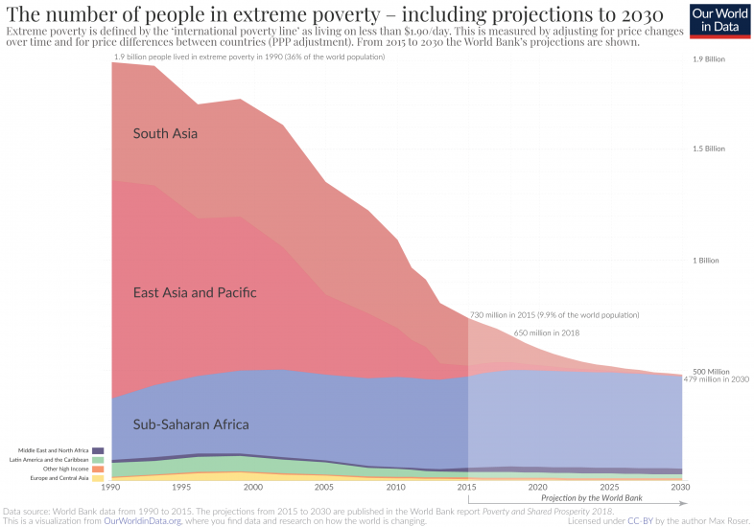
As you see, 30 years ago 1.9 billion people 36% of the world’s population lived in extreme poverty, mostly in Asia. Extreme poverty is life on the edge of death. In 2018, 650 million lived on the edge, about 9% of the world’s population. The great reduction in those living in extreme poverty is despite an increase in population of about 43%.

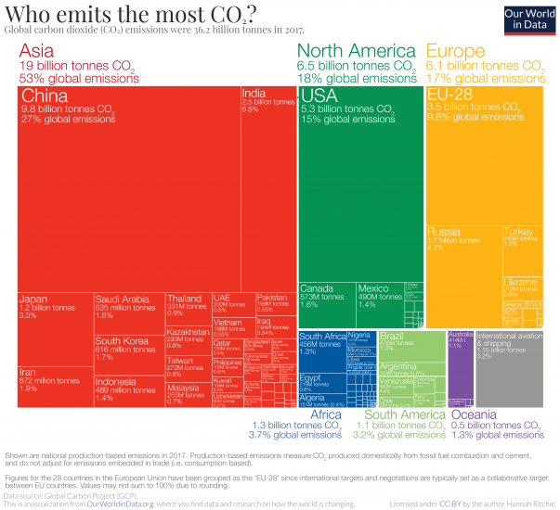
From 1990 through 2018 the world’s CO2 emissions increased by 60%. China’s CO2 emissions grew by 315%, more than three times. Today, Asia emits more CO2 than all other continents combined.

******************
A second remarkable change is Space Age Technology which gives us the ability to observe and measure what is occurring in the atmosphere, where the greenhouse effect occurs. This evidence contradicts that early scientific speculation. Despite a 60% increase the influence of CO2 on global temperatures is modest, and not dangerous.
******************
A third remarkable change is the obstinance of Western Governments and many western science institutions in ignoring the changing evidence. Contrary to the scientific method they are refusing to adjust their views, which they still call scientific, to the great expansion in physical evidence about the atmosphere and the effects of carbon dioxide. With mounting physical evidence, what began as a scientific speculation has drifted into world of science fiction and political myth.

Washington DC is a hotbed for science myths and attacking all who dare question them. Our honoree had already experienced what happens to physicists who challenge the accepted myths with physical evidence. In his experience in estimating precipitation, he always advocated those measurements must be checked and double checked, and when scientific concepts do not meet the evidence from experiments and observations, the concepts must be change. This winter, when given an opportunity he bravely stood up, and with the support of a few, declared certain myths popular in Washington are not science, and explained why.

Ladies and gentlemen, I have the privilege to present to you the honoree of the 2021 Fredrick Seitz Memorial Award, Dr. David Russell Legates

